**PRESS RELEASE**

**COMMUNICATIONS AND MEDIA TEAM OF THE 2023 ASEAN SUMMIT**

**No.55/SP/TKM-ASEAN2023/ENG/5/2023**

**Indonesia’s Communications and Informatics Minister Welcomes**

**Prime Minister of Timor-Leste at Komodo Airport of Labuan Bajo**

**West Manggarai, 9 May 2023 –** Prime Minister of Timor-Leste, Taur Matan Ruak, set foot at Komodo Airport of Labuan Bajo in West Manggarai Regebcy of East Nusa Tenggaa (NTT) province at around 14.00 pm Central Indonesian Time, Tuesday, 9 May,. He comes to attend the 42nd ASEAN Summit 2023 from 9-11 May 2023.

The Prime Minister flew with the Timor-Leste’s Aero Dili presidential aircraft and will attend the Summit as an observer.

The 42nd ASEAN Summit 2023 will discuss a road map that contained important elements such as legal instruments, financial contribution schemes, and strengthening of Timor-Leste State Civil Apparatus (ASN) capacity. This effort is part of the preparation made for the country’s full membership in ASEAN.

Prime Minister Taur was welcomed by the Indonesian Minister of Communications and Informatics, Johnny G. Plate. The arrival of Timor-Leste’s Prime Minister was welcomed by a welcoming ceremony with East Nusa Tenggara’s traditional dances. From Komodo Airport, the Prime Minister then headed to the 42nd ASEAN Summit 2023 venue.

Earlier this afternoon, at around 13.09 pm local time, Prime Minister of Cambodia, Hun Sen and Spouse Bun Rany arrived at the airport. Hun Sen was welcomed by the Indonesian Minister of Health, Budi Gunadi Sadikin.

The 42nd ASEAN Summit 2023 series of events will be attended by eight ASEAN Leaders, the Secretary-General of ASEAN, and the Prime Minister of Timor-Leste as observers. (TR/Elvira)

***

For more information, please contact:

**Director General of Public Information and Communications of the Ministry of Communications and Informatics – Usman Kansong (0816785320).**

Get more information at <http://asean2023.id>, <https://infopublik.id/kategori/asean-2023>, and <https://indonesia.go.id/kategori/ragam-asean-2023>

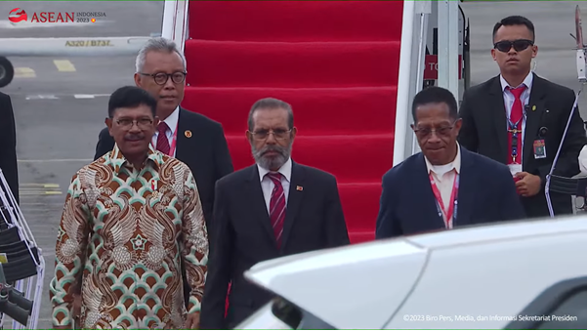

Prime Minister of Timor-Leste, Taur Matan Ruak, arrives at Komodo Airport of Labuan Bajo in West Manggarai Regency of East Nusa Tenggaa (NTT) province at around 14.00 pm local time, Tuesday, 9 May. He comes to attend the 42nd ASEAN Summit 2023 from 9-11 May 2023.